THE PARA-ECONOMIC PARADIGM: IMPLEMENTATION STRATEGIES
Michelle Dennis (formerly Charles M. Dennis),
Retired Director of Finance, City of Santa Monica, California,
Certified Public Finance Officer, Lecturer, Meyer and Renee Luskin Graduate School of Public Affairs, Public Policy Department, UCLA

Presented at the American Society for Public Administration 2019 Conference on March 11, 2019;
Panel – “Reconceptualizing Public Administration: Towards a New Paradigm of Public Governance and Societal Inquiry”

Overview

“The traditional approach followed by economists to measure human well-being focuses on the resources that individuals have at their command, which are usually assessed in terms of either money income or assets or the goods and services that they consume. However, although resources are clearly important for human well-being…, they are also clearly insufficient…. human well-being depends on what resources enable people to do and to be, and the ability to convert resources into a good life varies across people. This suggests that indicators that go beyond being measures of income, wealth and consumption and incorporate the non-monetary aspects of quality of life… have an important role to play.” (Stiglitz, page 141)

The issuance of the Report by the Commission on the Measurement of Economic Performance and Social Progress in 2009, along with other similar reports, began a global quest to identify measures of wellbeing of people to augment traditional measures of economic activity, and how to incorporate wellbeing measures into the public policymaking process. Implicit in this quest is the acknowledgement that the quality of human associated life is not merely about means-ends or economic reasoning (instrumental rationality) necessary to generate economic resources, but necessarily also involves values/ethical, wellbeing reasoning (substantive rationality) that enables people to determine not only for what the economic resources will be used but also why. (1)

In what follows, I argue that fulfilling this quest requires a way to understand societies that goes beyond only economic thinking and that provides a context that accommodates a multidimensional notion of citizen wellbeing. The Para-economic Paradigm put forth by Alberto Guerreiro Ramos in his book The New Science of Organizations: A Reconceptualization of the Wealth of Nations provides just such a context. Specifically, I argue that the Para-economic Paradigm which provides a defined multidimensional view of societies makes possible and legitimatizes values/ethical or wellbeing reasoning in public policy decision making. In this way, it also provides a new “lens” through which emerging major issues that will soon confront public administrators and the field of Public Administration can be newly examined to identify public policy possibilities which so far have not been seen or are seen as not being practical using the traditional “lens” of means-end, economic reasoning. (2)

To present my argument, I briefly look at how the Para-economic Paradigm can open up new public policy possibilities for adapting society and its institutions to deal effectively with the future of productive effort, and for adapting local government budget processes to include the concept of wellbeing in resource allocation decisions.
My argument springs from the perspectives of having been a public administration practitioner for almost 40 years, and a lecturer to graduate students teaching public budgeting and finance for almost 15 years.
Finally, this paper is intended to be a thought piece which will provoke discussion and debate, and therefore, it should be considered a starting point for a much broader and in-depth future inquiry.
The Para-economic Paradigm

“In this book I set forth the conceptual framework for a new science of organizations. My objective is to contrast a …[multidimensional] model of social systems analysis and organizational design with the current market-centered model which has dominated private enterprises and public agencies for the last eighty years. Generally, I argue that a market-centered theory of organizations is applicable not to all, but only to a special type of activity. Attempts to apply its principles to all forms of activity are hindering the actualization of possible new social systems needed to overcome the basic dilemmas of our society……I suggest that the manner in which the dominant model is taught is deceptive and has disastrous consequences since the limits of its functional character are not acknowledged.” (Ramos, page IX)
“Central to this multidimensional model is the notion of organizational delimitation. This notion implies (1) a view of society as constituted by a variety of enclaves (of which the market is but one) in which man engages in distinctly differing, yet truly integrative, types of substantive pursuits, and (2) a societal governance system able to formulate and implement allocative policies and decisions required for optimal transactions between those social enclaves.” (Ramos, page 121)

“The multicentric society is a deliberate undertaking. It implies design and implementation of a new kind of state empowered to formulate and enforce allocative policies supportive not only of market-oriented pursuits, but of social settings suited for personal actualization, convivial relationships, and community activities of citizens as well.” (Ramos, page 135)

The following diagram presents the Para-economic Paradigm. For a complete exposition of the paradigm and its dimensions and characteristics, see Chapter 7 of The New Science of Organizations: A Reconceptualization of the Wealth of Nations. (Ramos)

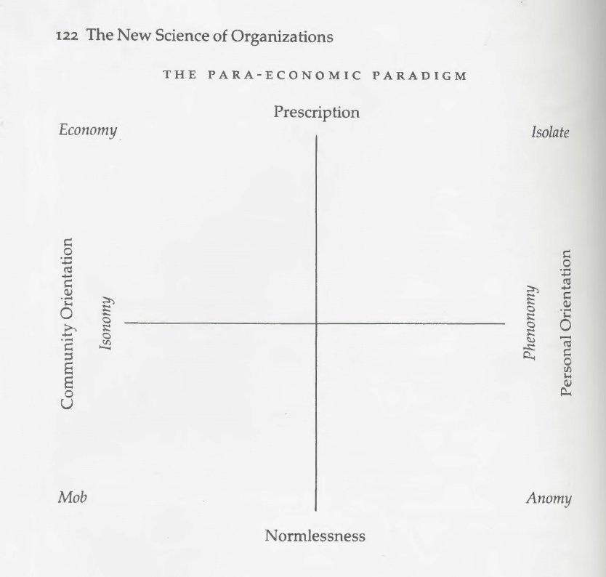
Each of the variety of societal enclaves envisioned by the Para-economic Paradigm requires their own unique design and management skills and tools. Designers of and participants in the variety of enclaves employ nuanced concepts of how technology is to be used, size, varieties of knowledge (cognition), space and even time, rather than be controlled by market dominated understandings of these concepts. However, Ramos is careful to point out that the social enclaves presented in his new paradigm are “….heuristic constructs in the Weberian sense. No situation in social life is expected to coincide with these ideal types. In the concrete world, only mixed social systems exist.” (Ramos, page 121).
Further, Ramos asserts that: “Social systems delimitation [organizational delimitation] postulates a variety of differentiated settings as vital imperatives of sound human associated life, i.e. it implies that men’s actualization is thwarted when they are coerced to conform to a society pre-empted by the market or any other social enclave.” (Ramos, page 136)

Now, for the purposes of examining how to adapt to the future of productive effort and how local budget processes can incorporate wellbeing, two social enclave constructs require a bit of elaboration: Isonomy and Phenonomy. Examples already exist in various forms in society, however, public policy makers largely understand them from the conceptual framework of the economic enclave. Specifically, they are primarily understood as additional spaces to facilitate the delivery of public services in the form of coproduction (3), and/or as sources of jobs the output of which are only measured by standards of economic activity relevant to the economic enclave. From the lens of the economic enclave, they are not seen as separate and useful social settings for productive activities contributing to national wealth primarily because their output is not measured by standards relevant to the economic enclave. Historically, they have also not been seen as integral and paramount for defining and addressing wellbeing of citizens. Disentangling them from the economic enclave lens is possible by using the Para-economic Paradigm. When disentangled, we begin to see that they can play an enhanced and vital role in the functioning of societies. (4)

Let’s take a closer look at each enclave.

Isonomy

“In general, Isonomy can be defined as a setting in which its members are peers…..Isonomy is conceived as a true community in which authority is assigned by common deliberation……arrangements in which ultimately people are searching for styles of life which transcend the dominate normative standards at large. (Ramos, pages 131-132).

Key characteristics are:

- “Its essential goal is to allow the actualization of its members free from superimposed prescriptions.
- It is largely self -gratifying in the sense that in it freely associated individuals accomplish activities that are rewarding in themselves
- Its activities are undertaken primarily as vocations, not as jobs. In isonomies people work; they do not labor. In other words, their basic reward is the accomplishment of their works’ intrinsic objectives, not the revenue eventually drawn from their doings. Thus, utility maximization is incidental to the individual’s basic concerns.
- Its decision and policy-making system is all inclusive. There is no differentiation between the leadership or the management and the subordinates.
- Its effectiveness requires that primary interpersonal relations prevail among its members.” (Ramos, pages 131-132)

Some typical examples are: “…PTAs (Parent-teacher associations), student and minority associations, urban communities, worker-owned firms, some artistic and religious associations, local associations of consumers, groups and citizens concerned with community issues and problems…” (Ramos, page 132)

Phenonomy

“This is a breakthrough social setting, either sporadic or more or less stable, initiated and run by an individual or a small group. It entails for its members the maximum degree of personal choice and a minimum degree of subordination to formal operational prescription.” (Ramos, page 132)

Key characteristics are:

- “It is constituted as a setting necessary for people to release their creativity in autonomously selected forms and ways, and is part of the expressive endeavor…..which mobilizes the creative efforts of a small group or a single individual.
- Its members are engaged only in self-selected works.
- Although the output of activities undertaken in phenonomies can eventually be marketable, economizing criteria are incidental to the orientation of their members.
- Although concerned with his or her uniqueness, the member of a phenonomy is socially mindful. Actually, his or her choice is not to withdraw from society at large, but to sensitize other individuals for possible experiences that they are able to share or appreciate.” (Ramos, pages 132 – 133)

Some typical examples are: “…The gifted housewife and husband who systematically reserve a spot in their home to engage in creative pursuits like design and production of rugs, pottery, or paintings, as well as the workshops of free-lance artists, writers, journalists, craftsmen, inventors and so forth.” (Ramos, page 133)
Once distinguished, we can start to see that Isonomies and Phenonomies can expand the playing field for the development and implementation of public policy. To explore this notion further, lets look more closely at two major problems that are about to confront administrators and the field of Public Administration: the future of productive effort where the traditional concept of a job may no longer apply, and the future of local government budget processes which may be called upon to allocate resources not only to deliver public goods and services but to also to bring about wellbeing of its citizens.

The True Wealth of Nations---The Future of Productive Effort

“We have come to the point where we must make the nonproducer a consumer or we will find ourselves
drowning in a sea of consumer goods… The problem indicates that our emphasis must be two-fold. We must
create full employment or we must create incomes. People must be made consumers by one method or the
other. Once they are placed in this position, we need to be concerned that the potential of the individual is
not wasted. New forms of work that enhance the social good will have to be devised for those for whom
traditional jobs are not available.

In 1879 Henry George anticipated this state of affairs when he wrote, in Poverty and Progress:

‘The fact is that the work which improves the condition of mankind, the work which extends knowledge and
increases power and enriches literature, and elevates thought, is not done to secure a living. It is not the work
of slaves, driven to their task either by the lash of a master or by animal necessities. It is the work of men
who perform it for its own sake, and not that they may get more to eat or drink, or wear, or display. In a state
of society where want is abolished, work of this sort could be enormously increased.’ ” (King Jr., page 172-
173)

As I previously indicated, a fundamental problem soon to confront public administrators and the field of Public Administration is how to adapt the design of our current society and its institutions to deal with the future of productive effort. The very definition of a “job,” how a job is related to the distribution of income, how to continue to provide social and economic security, how best to prepare people to participate in the future work environment through re-skilling and up-skilling to increase adaptability and resilience, and how best to deal with the ensuing economic and social disruption due to the coming very rapid advances in information technology (IT) and artificial intelligence (AI)---all these questions and how they should be answered are very much “up in the air,” so to speak.
However, some initial outlines of responses to these questions have already begun to emerge. The broad parameters seem to be:
- “Contingent work will expand as a result of the continued use and development of computer-based information technologies and business models based on web-based matching algorithms.

- With the decline of unionization, the prevalence of contingent work, and a more mobile workforce, new institutions that also offer workers a greater voice in their workplace and in the political arena are becoming increasingly important for worker fairness and equality.

- Because work has become increasingly nontraditional (detached from single employers over the course of a career), enabled in part by technology, employment institutions may need to change in order to provide all workers with access to health care, pension funds, and other elements of the social safety net that have been historically tied to full-time traditional employment.

- Because of the increasing ability to use IT to reduce the need for co-location, a widening geographical division of labor is likely to continue, and new ways of organizing that preclude regular face-to-face interaction will emerge, at least for those tasks in which direct interaction is not essential.

- To the degree that IT alters the skill structure on which the division of labor is based, educational systems will need renewed attention. Although encouraging more young people to pursue a college education and acquire the skills needed for service-oriented jobs or for STEM fields makes sense, these efforts will not be sufficient; strategies for strengthening social and other uniquely human skills and enabling flexibility in the face of changing circumstances will likely be important.

- The exact nature of the changes depends not only on technological advances, but on a complex interplay of skills, organizations, institutions, culture, and policies. There is no guarantee that economic and social changes will be gradual or that they will be beneficial for everyone. Unanticipated breakthroughs not only in technology, but in any of these other factors, or in their interaction, could lead to large-scale disruption of the status quo.” (National Academies of Sciences, Engineering, and Medicine)
What are the implications for policy makers, organizations and individuals? Again, some initial thoughts have emerged:

- “Reassess policies. In order for individuals and organizations to keep pace with the changes in the future of work, it is necessary for societal institutions to reassess legal and regulatory policies. Governments in particular should consider updating the definitions of employment to account for freelance and gig economy work and the provision of and access to government health, pension, and other social benefits…..

- Redesign work for technology and learning. To take effective advantage of technology, organizations will likely need to redesign work itself, moving beyond process optimization to find ways to enhance machine-human collaboration, drawing out the best of both and expanding across alternative workforces.

- Reimagine lifelong education. It is anticipated that the half-life of skill sets will decrease to five years in the future of work. Individuals embarking upon a 30-year career would have to update and refresh their skills six times throughout their careers. Ecosystems should be ready to rethink through education and establish a framework to help everyone develop their talent more rapidly. This focus on education should extend to marginalized populations and older generations who do not want to or cannot transition out of the workforce. In addition, payment structures and incentives could be designed to support this approach to lifelong education: facilitating access to ongoing education and training throughout a working career that might span 50 years and many different types of work.” (Schwartz, Monahan and Stockton).
As we struggle to flesh out solutions to these issues, I would assert that there is something that so far has largely not been seen that is constraining what we consider are the range of options we believe are possible and practical: we are primarily using the “lens” of the market place or economy, with all of its underlining assumptions about who we and others are and our definition of what “works.” For example, the above seems to assume that jobs will continue to be the mechanism for providing income, that it is paramount to ensure that all workers continue to be job holders, and should people fall out of a job we must very quickly and effectively re-train/re-educate them to be employed in the new jobs of the future.
However, if we substitute the “lens” of the Para-economic Paradigm, we could begin to consider the possibility that a job in the market economy may not be necessary to provide a living income to all people, that not all people can or should be employed in a job in the economic enclave in order to be productive and to contribute to society, that productive effort can happen in social enclaves other than in the market economy, and that perhaps the true wealth of nations comes from productive efforts that occur in all societal enclaves. (4)
Let’s see how this new possibility could work.
Previously, I examined the conflicting demands in the United States between economic efficiency and economic equality (Dennis, 2006). I believe that this issue has been conceptually dead-ended into how to limit the gap between the rich and poor by either expanding participation in the market enclave through reallocating the incremental increase of an expanding economy, or through income redistribution in a relatively static economy. However, if one were to look at this issue through the lens of the Para-economic Paradigm, an alternative and ultimately less expensive and more humanly gratifying strategy seems possible.
As shown by the following two diagrams, I conducted a theoretical analysis of the relationship of those market enclave participants whose control over productive power in the market enclave is greater than their own personal productive power (economically advantaged people) versus those whose control over productive power in the market enclave is less that their own personal productive power (economically disadvantaged people). As a result of this analysis, I concluded that it could cost much less to reallocate wealth/income to enable economically disadvantaged market enclave participants to remove themselves to some degree from the market enclave and still participate in productive efforts in isonomies and/or phenonomies than to reallocate wealth/income to transform them into economically advantaged market enclave participants through re-education and/or re-training---perhaps by one-half. (5)

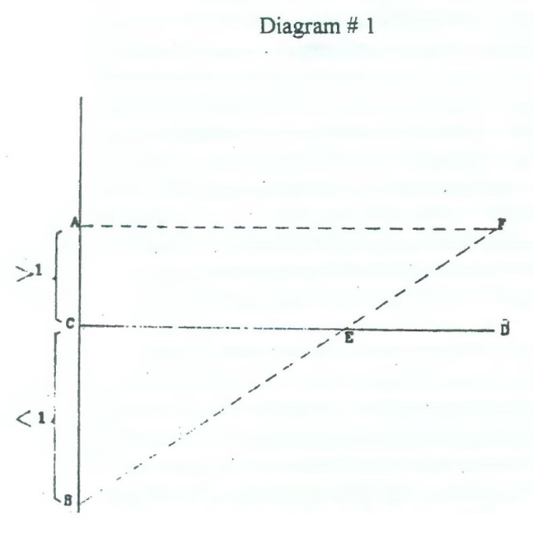 | 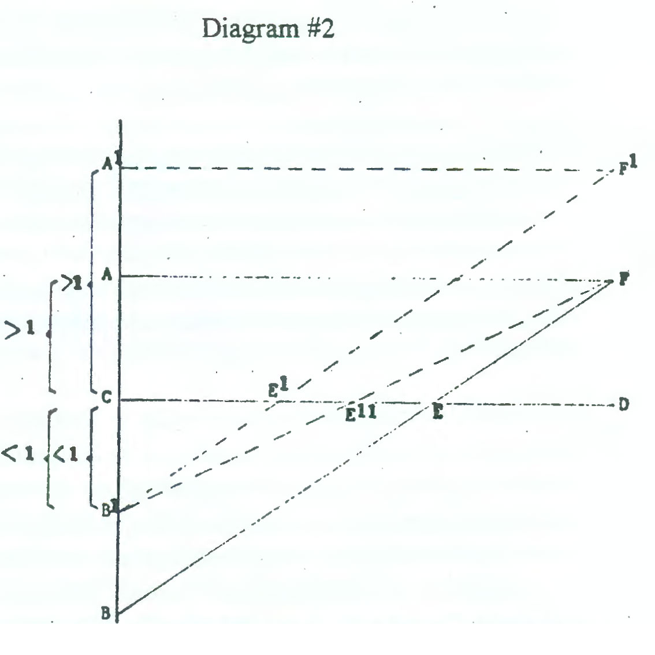
- A-B is the number of persons participating in the market (price-exchange) system.  - A-C is the group whose control over personal productive power is greater than their own personal productive power.  - C-B is the group whose control over personal productive power is less than their own personal productive power.  - C-D is the total number of people in the population.  - E-D is the number of people who own a controlling share of the means of production in the society. (e.g. 50%+)  - C-B-E is the power of the advantaged groups: A-C/E-D.  - F-E-D is the power of the disadvantaged groups: C-B/C-E. | - To increase the power of the disadvantaged group(s), the traditional approach it to redistribute wealth/ income and thus increase the number. of people, D-E to D-E1 owning a controlling share of the means of production, while decreasing the number of power disadvantaged people in the market by B-B1.  - Alternately, a reduction of the same number of power disadvantaged people in the market could be achieved by a lesser redistribution of wealth/income, to Ell rather than El, if the B-B1 group were removed from market processes.

If this analysis is correct, what could be the source of funding to be reallocated that would enable people to seek to be productive in settings other than the economic enclave? One option could be to institute a Uniform Basic Income (UBI) program to completely or partially replace current social safety net program transfer payments and the associated administrative costs.
The notion of the state establishing a Universal Basic Income (UBI) can be traced back to the 16th century in the writings of Sir Thomas More (Utopia). During the 20th century, this idea was widely discussed, and since 2000 there have been several experiments looking at if a UBI system could replace means tested/work (i.e. “job”) required welfare systems. Recently, the United States National League of Cities in October 2018 issued its Basic Income in Cities: A Guide to City Experiments and Pilot Projects which stated that “The proposal [UBI] represents a scalable solution that can help us reimagine and improve our social safety net, while encouraging us to reflect on the deeply changing nature of work.” (page 3) In fact, the City of Stockton, California just initiated such a pilot program. (6)
Now, what if we employed a UBI system not only to fully or partially replace current means tested/work required social safety net programs and associated administrative costs, but also as a means for channeling productive effort into isonomic and phenonomic settings for people desiring to not be job holders and/or who are temporarily withdrawing from being a job holder? Such a strategy would certainly add to national wealth even though these activities are not currently counted in GDP calculations. These activities could include volunteering, household management and child rearing, and other productive activities funded by one-way financial transactions (i.e. grants) in addition to UIB payments.

If such a strategy were implemented, we would then require some means to measure the currently uncounted benefits to society from these new productive efforts. One way to measure such benefits would be to employ the concept of wellbeing. The goal would become be to identify wellbeing factors (i.e. goals and objectives), as defined and continually redefined by the affected citizens, and institute a process for measuring progress in meeting those goals and objectives.

Such efforts are currently underway in the United Kingdom (UK) and in various OECD countries. Based on eight years of effort, in the UK the Office of National Statistics (ONS) has created 43 indicators of well-being (organized into nine categories such as Personal Well-being, Relationships, Health, etc.). The process of creating these indicators involved extensive citizen input. ONS has been tracking and reporting the data related to these indicators annually to enable its citizens and policy makers to measure the quality of life as well as the status of its economy.
Next, with factors and measures of wellbeing in hand, the next step would be figuring out how to consider wellbeing measurements in public policy making and budgeting processes. A first effort in this direction is happening in New Zealand. The preparation of the country’s 2019 national budget, to be released on May 30, 2019, is being guided by The New Zealand government’s 2019 budget policy statement:
“This Budget Policy Statement (BPS) sets out the Coalition Government’s priorities for the 2019 budget. This will be New Zealand’s first Wellbeing Budget and so, for the first time, the BPS contains a Wellbeing Outlook (instead of just an Economic and Fiscal Outlook) that describes the current state of wellbeing in New Zealand and what this may mean for future wellbeing….The BPS also describes the Government’s wellbeing approach and how it is being used in the Budget process. The wellbeing approach has helped us identify the actions we believe will make the greatest contribution to improving the intergenerational wellbeing on New Zealanders.” (The Treasury, page 1)
While this first effort is to be commended, a critical element seems to be missing: robust interaction with citizens to not only help define appropriate factors and measures of wellbeing, but to also help create programs that would produce the desired wellbeing program outcomes and to monitor program implementation. As the following shows, New Zealand continues to follow a “technocratic,” budget development and implementation practice that is commonly followed in governments around the world, rather than a citizen participation approach. In essence, the technocratic approach assumes that budgeting is done by professionals using technical methods to achieve the best allocation of resources given the goals of the government. Public participation is largely relegated to being informed about what the professional come up with and reacting to their specific proposals.
“The priorities [of the Budget Policy Statement] represent five areas where initial evidence from the LSF [Living Standards Framework] and other sources show that substantive opportunities exist to make a difference to New Zealanders’ wellbeing. They were refined through a process of consultation with officials, Ministers, sector experts, and Government Science Advisors, and combined with other inputs including the Child Wellbeing Strategy and international evidence” (The Treasury, page 22)
So, looking at the issue of the future of productive efforts through the lens of the Para-economic Paradigm, we get five elements of a new and potentially viable strategy:
- The possibility of designing a society where productive efforts could occur in many different social enclaves, not only the economy, and where those productive efforts can expand the understanding of a society’s wealth;

- Using measures of wellbeing as guides to the establishment and the nurture of those other social enclaves;

- A means to provide a non-means tested/work required source of income (such as UBI) to people participating in productive efforts in social enclaves other than the economy;

- Employing a budget process adapted to incorporating wellbeing as a policy priority through the use of one-way allocation of resources (7); and

- In addition to “technocratic” budget development, also creating robust opportunities for citizens to participate in the design and nurture of the other social enclaves, the definition of wellbeing factors and associated performance measures, and the creation of programs to produce the desired wellbeing outcomes.
We now turn to the fourth and fifth elements of this new strategy: adapting budget processes and creating robust citizen participation. I will argue that full implementation of these two strategic elements require two-way transparency, meaningful citizen participation and outcome-oriented accountability measures developed in partnership and collaboration with citizens, and reported to the public. It is to these matters that we now turn.

Wellbeing and the Future of Local Government Budget Processes

“If you ask 20th century City Managers and city staffs what is their fundamental job, they will probably
answer it is to provide local public services efficiently and effectively. We certainly know how to do these
things. However, if you ask the same question of 21st century City Managers and city staffs, the answer is starting to take the form of another question: for what purpose are city services being provided, and the answer is starting to be for Wellbeing. This changes almost everything.” (Rick Cole, City Manager, City of Santa Monica in a lecture to graduate students in a Public Budgeting and Finance Class, May 29, 2018, Meyer and Renee Luskin School of Public Affairs, Public Policy Department, UCLA)

Modern public budgeting in the United States originated during the opening years of the 20th century in the work of government officials, academic reformers, and staff members of municipal research bureaus (such as the New York Bureau of Municipal Research), and was focused on accounting and reporting of public expenditures, and for the executive to take more responsibility for governmental budgeting. (Rubin, 1993) Building on these efforts, the Taft report of 1912 called for the establishment of a Federal executive budget process that resulted in the adoption of the Federal Budget and Accounting Act of 1921.

However, paralleling these initial reform efforts to install powerful executive led budgeting was the work of others which focused on educating the public so they could hold the executive accountable for budgetary decisions and results. In fact, they argued that informed public participation was critical to the success of executive budgeting. (Myers and Rubin, 2011) However, over the ensuing century, executive budgeting has become what I have called “technocratic” based on the idea that cost efficient and effective service delivery is the goal and is best accomplished by budget professionals employing highly technical analytical tools, and “public input” constitutes seeking responses from the public about what the professionals are proposing. As a result, robust participation of an educated public overseeing the process, engaged in the joint creation of programs and demanding accountability has not been fully implemented. (Williams, 2003, Ebdon and Franklin 2006, and Myers and Rubin, 2011). Generally, this has contributed to a decline in public trust and confidence in government, and a feeling of powerlessness on behalf of citizens.

The introduction of the idea that the job of cities and city staffs is to help bring about the wellbeing of its citizens opens the door for reconsideration of the notion of an informed and empowered public actively engaged in the creation of their wellbeing. For this notion to flourish, the nature of local budget process must be expanded beyond technocratic process designs.

Over the last several decades, the City of Santa Monica, California, has been somewhat of an exception in this regard. Widely recognized as a well-managed and fiscally very prudent, the city has also prided itself on the involvement of its citizens in local government. Nevertheless, its budget process remains essentially technocratic. Within this context, about 5 years ago, Santa Monica took on becoming the first city in the world to create a Wellbeing Project. (8) Wellbeing dimensions (factors) have been identified and data indicating how the city is performing along those dimensions is being collected and analyzed. The analysis indicates that progress is being made. Surveys of citizens have been incorporated into the process. Last year, the City instituted micro grants to address some quality of life matters through small scale citizen designed and implemented programs in one of its neighborhoods. The use of microgrants in this manner represents an initial step beyond the confines of a technocratic-oriented budget process. Currently, the city is looking at how to incorporate its wellbeing work more broadly into the annual budget process.

Going forward, the City of Santa Monica as well as other cities which may be focusing on wellbeing, could gain insight into new non-technocratically limited possibilities for viewing the city, the role of City government, and how to better use the budgeting process by looking at these matters through the lens of the Para-economic Paradigm. Traditionally, City government’s view of the city and its role has been to generate sufficient revenues from the local economy and other sources to provide an appropriate mix of public goods and services which support the well-functioning of the city as a place to live and work. Consistent with these views, the local budget process has become the means for allocating those revenue resources to produce an appropriate mix of publicly delivered goods and services. Using the lens of the Para-economic Paradigm, the role of City government could be substantially expanded. City government could become the primary catalyst through its budget process for the nurturing of existing and the creation of new productive efforts by individual citizens and all manner of citizen led groups specifically focused on enhancing collective wellbeing in isonomic and phenonomic-like settings throughout the city as well as City operated programs, delivered directly and/or through coproduction arrangements.

To take on this expanded role, City government would have to adopt a three-pronged strategy to fundamentally alter city staff’s relationship with its citizens. This strategy would entail: implementing a new citizen-administrator relationship, establishing two-way transparency between citizens and administrators, and employing outcome-oriented performance measurement and management systems.

New Citizen-Administrator Relationship

When administrators take on the challenge of creating wellbeing for citizens, not just cost efficient and effective service delivery, technocratic oriented operations and budgeting is simply insufficient: defining what “wellbeing” means and how to measure it also requires meaningful involvement of those whose wellbeing is at stake; and creating and implementing wellbeing programs which are imbued with legitimacy and supported by those they are designed to impact also requires extensive and on-going citizen involvement. In short, what is required is a shift from trying to involve citizens in city programs to the city becoming interested in how citizens actually live their lives, and what would improve citizen well being as defined by the citizens.

Achieving this shift, requires altering the citizen-administrator relationship from “Informing Citizens” to “Empowering Citizens.” (Nabatchi, 2012) This involves what King (1998) calls replacing Conventional (Unauthentic) Participation with Authentic Participation as shown by the following figures and comparison table. In essence, we must go from the administrator using and managing administrative systems and processes to define issues, soliciting information from citizens, crafting solutions and then informing citizens what is being done, to the administrator (backed up by administrative systems and processes) empowering citizens to help define and find solutions to issues and then facilitating the implementation of those solutions with full citizen participation. For this shift to be accomplished, administrators (including budget directors and budget staff) must have additional skills (e.g. interpersonal, discourse and facilitation) and be skilled in a very wide range of public participation techniques. Unfortunately, development and teaching of these personal skills and public participation techniques are largely not provided in current Masters of Public Administration programs.

Table 1
Comparison of Authentic and Unauthentic Participation
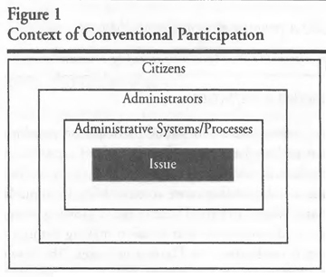 | 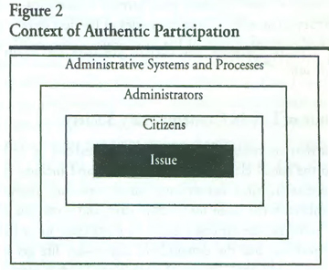

Interaction style  Participation is sought  Role of administrator  Administrative skills  needed  Role of citizen  Citizenship skills  needed  Approach toward "other"  Administrative process  Citizen options  Citizen output  Administrator output  Time to decision  Decision is made | Unauthentic Participation  Conflictual  After the agenda is set and decisions are made  Expert technician/manager  Technical; managerial  Unequal participant  None  Mistrust  Static, invisible, closed  Reactive  Buy-in  Decision  Appears shorter and easier but often involves going back and "redoing" based upon citizen reaction  By administrator/political and/or administrative processes perhaps in consultation with citizens | Authentic Participation  Collaborative  Early; before anything is set  Collaborative technician/governor  Technical, interpersonal skills, discourse skills, facilitation skills  Equal partner  Civics, participation skills, discourse skills  Trust  Dynamic, visible, open  Proactive or reactive  Design  Process  Appears longer and more onerous but usually doesn't require redoing because citizens have been involved throughout; may take less time to reach decisions than through traditional processes  Emerges as a result of discourse; equal opportunity for all to enter the discourse and to influence the outcomes

Some elements of an Authentic citizen-administrator relationship have already begun to emerge with the use of Participatory Budgeting (PB). PB began in 1989 in Porto Alegre, Brazil. It is a process whereby local citizens are empowered by City staff and elected officials to determine how a specified amount of funds made available by the City will be spent in their neighborhood on uses that the citizens unilaterally determined. Various versions of this process have been implemented in over 3,000 cities around the world and since 2009 in 16 cities in the United States. The largest PB in the United States is in New York City where 30 council districts are doing PB. (9)

Here is what complete Authentic Participation could look like in a typical local government budget process that follows a July 1 to June 30 budget cycle where programmatic outcomes contributing to citizen wellbeing are being sought:

- Before the process of preparing a City budget for the coming budget cycle begins, citizen stakeholders are coached in: how to read and understand the jurisdiction’s budget and wellbeing measures; the current programs being implemented by each department; other nongovernment programs throughout the City that are also seen as contributing to citizen wellbeing, applicable revenue sources; legal constraints and requirements of programs; how the city’s administrators will interact with citizen stakeholders and what is expected of citizen stakeholders.

- During the Summer and early Fall of the fiscal year before the coming new budget cycle, City program departments intentionally interact with stakeholders for all programs (City operated and non-City operated) to help define what program modifications and/or new program resources or service levels may be needed for the coming new budget cycle;

- During the Fall, baseline projections of fiscal and wellbeing outlooks for the coming new budget cycle and additional out years are prepared (given projected economic and other non-economic factors) and presented to jurisdiction citizen stakeholders for discussion, and the crafting of possible budget scenarios for the new budget cycle are explored with citizen stakeholders in light of baseline projections.

- Once the City governing body (e.g. City Council) sets a budget and wellbeing policy (e.g. an increase, no change or decrease) ---usually done during early January--- to guide preparation of the coming budget cycle budget proposal from city staff, program departments continue to work with all citizen stakeholders as part of prepare their budget requests.

- During the review of program department’s budget requests by the jurisdiction’s executive (Mayor or City Manager), appropriate citizen stakeholders are also consulted.

- During the traditional annual budget adoption public hearing before the City Council (usually during June), stakeholders may testify but only for purposes of fine-tuning the staff proposed budget, rather than commenting on it for the first time.

Authentic citizen participation also requires moving from merely making more information available and accessible to citizens to a two-way transparency relationship between the City and its citizens.
Establishing Two-Way Transparency
Considerable progress has been made over the last decade or so in providing more one-way financial and budgetary transparency in the United States, essentially at the local and state levels. Examples of one-way transparency are making complete budget documents and financial reports available to citizens online. In some cases, citizens can even drill down to specific financial transactions, and can create graphical representations of financial and budgetary information. However, jurisdictions usually do not coach citizens in what the information means or how to relate the information to policy matters. So, even though more information is available, citizens are at a considerable disadvantage in being able to understand or use it effectively. In short, this type of one-way transparency does not alter basic power asymmetries. Citizens may see the results of governmental actions, but they cannot see and understand exactly what has happened and how it happened.
In some jurisdictions, citizen groups and/or non-profit organizations have taken up the mantel to overcome this transparency gap by providing financial and budget intermediation services to citizens. However, very often these budget intermediation providers, themselves, face the same information and understanding constraints as experienced by the citizens they seek to serve. (10)
Opening the “information window” wider so that citizens can not only have access to more information, but can also understand it, use it and even be able to monitor what is being done and how it is being done would move us closer but not all the way to two-way transparency. Two-way transparency involves altering power relationships so that neither citizens nor governmental staff can unilaterally determine important policy outcomes on matters that directly impact citizens wellbeing. (World Bank, 2017) (11) Empowering citizens in this matter, moves the transparency relationship from informing citizens to collaborating, partnering and joint learning with citizens. An empowering transparency relationship creates the context for increasing trust, confidence and joint ownership of program outcomes to arise. (Meijer, 2013)
Here is what two-way citizen empowering transparency could look like in a typical local government budget process that follows a July 1 to June 30 budget cycle where program outcomes that contribute to citizen wellbeing are being sought:
- The local government has completed a strategic planning process. The process has extensively involved its citizens in identifying where social, economic and political trends seem to be taking the city into the future, what the citizens want the city to look like in the future, and what role city government is to take in creating/helping to create the desired vision of the future city. The strategic planning process would acknowledged that the role of the City would not only be to provide governmental goods and services, but to also partner with other non-government efforts in isonomic and phenonomic-type settings throughout the city to achieve the strategic wellbeing goals of the City.

- As part of its strategic planning, citizens and city staff have jointly identified the key wellbeing factors and indicators that are to be used to evaluate if program outcomes are actually creating the desired vision of the future city. Citizens participate in developing indicator monitoring systems, and in revising those monitoring systems as necessary over time.

- There is an on-going process, potentially providing the opportunity for every citizen, to continually assess the relevance of wellbeing factors and indicators to their lives.

- Citizens have on-going access to participating in the development of budgets and the programs that result in resources being allocated to achieve specific wellbeing-related outcomes.

To complete our three-pronged strategy, we also require an effective process for monitoring progress in achieving the desired wellbeing outcomes. We need an array of wellbeing performance measures and a performance management system
Outcome-Oriented Performance Measurement and Management Systems
Over the last several decades, local and state governments in the United States have begun to identify various performance measures, collect periodic data and report performance results (usually in budget documents but only reflective of governmental programs). However, performance results have at best mostly been used by program managers to adjust operations. Rarely have performance measures been used to assist in resource allocation decision making. What has been missing is a direct and meaningful linkage between the selection of performance measures and confirmation by citizens that selected performance measures are, indeed, relevant measures of the quality of their everyday lives. What has also been missing is a mechanism to demonstrate to citizens that resource allocation and program management decisions have been made to directly improve performance, and the commitment to report, over time, progress in achieving the results the performance measures are supposed to measure.

Here is what an outcome-oriented performance measurement and management system could look like in a typical local government budget process that follows a July 1 to June 30 fiscal year where program outcomes that contribute to citizen wellbeing are being sought:

- Citizens are extensively involved in evaluating whether existing local government and non-governmental programs and service levels are addressing the wellbeing factors previously identified. This is not a one-time evaluation but is an ongoing evaluation process which involves extensive citizen participation.

- All budget process proposals to alter the design of service programs and/or alteration of program service levels explicitly demonstrate a relationship to wellbeing factors and their associated performance measures

- At least annually, there would be a State of the City Wellbeing Report issued by city management or the City Council to all citizens. This report would include information indicating whether progress on meeting wellbeing performance measures has been made or not, and recommendations for program re-design and/or new programs to further wellbeing realization.

- The State of the City Wellbeing Report would encompass all productive efforts in the city contributing to desired wellbeing outcomes: city government efforts and efforts by no-profits and citizen led efforts. How all of these productive efforts are collaborating and cooperating/could collaborate and cooperating would be also be identified.

- City management/City Councils would seriously consider using one-way allocations of local government resources (grants) to non-governmental entities to achieve wellbeing outcomes. In such cases where one-way grants are used, local government staff provides technical expertise, the collection of performance measurement data, and administrative oversight to ensure that public resources are used appropriately. (12)
This three-pronged strategy recognizes that achieving wellbeing objectives is beyond the reach of only City government operations functioning independently. The role of City government operations would become to not only provide governmental goods and services, but to also marshal together and help coordinate the total associational resources of the city and its citizens.
Conclusion
“The Kuhn Cycle:
- [We start with] Normal Science [which] means research firmly based upon one or more past scientific achievements, achievements that some particular scientific community acknowledges for a time as supplying the foundation for its further practice.
- When issues, problems, or phenomenon appear the model cannot handle, the model begins to drift away from Normal Science. As soon as more than a small amount of drift occurs, the field's paradigm is said to be in Model Drift.
- In this step a field's model of understanding has drifted so far, the field is thrown into crisis, because they can no longer make rational decisions [Model Crisis]
- In this step a field's model of understanding is undergoing revolutionary change. The old model failed, which caused the Model Crisis step. The Model Revolution step begins when one or more competing new models emerge from the crisis.
- In the Paradigm Change step, the new paradigm is taught to newcomers to the field, as well as to those already in it. When the new paradigm becomes the generally accepted guide to one's work, the step is complete. The field is now back to the Normal Science step and a Kuhn Cycle is completed.” (Thwink.org Inc., summarizing Kuhn)

With respect to addressing the future of productive effort and adapting local budget processes to incorporate/create wellbeing for its citizens, I have argued that only coming from the economic enclave, and technocratic budgeting is not rational (instrumentally or substantively) because successfully responding to these matters requires solutions that span all societal enclaves in the city.

Concerning the future of productive effort, it is not rational to assumed that the only task is to so adapt society and its institutions so that as IT/AI generated disruptions occur everyone must reskill or upskill as a job holder to continue to be competitive in the economy enclave or fall into a social safety net program until they are reskilled or upskilled. Fulfilling this assumption is probably cost prohibitive and unrealistic for all people wishing to not be a traditional job holder but, nevertheless, still be productive and contributing to society.

Concerning local government budget processes, it is not rational to assumed that only more and/or better technocratic budgeting will produce on an on-going basis the correct mix of programs/service levels that will produce wellbeing for citizens that citizens consider as legitimately addressing their lived needs, and that it is not necessary to meaningfully involve them, except as information providers and reactors, in the process.

In both cases, it seems to me that the currently dominate economic enclave and technocratic decision model is in Kuhn Cycle Model Drift step and is likely soon to be in Kuhn Cycle Model Crisis step.

I have tried to show in this brief paper that looking at both issues through the Para-economic Paradigm opens up new possibilities and could possibly take us into the Kuhn Cycle Model Revolution step. I have also tried to sketch out the parameters of the new possibilities applicable to each issue.

Now, let the debate and discussion begin!

Notes:
- It is beyond the scope of this paper to delineate the theoretical distinctions between instrumental and substantive rationality, and to explore the applicability of these distinctions for public administration and organizations. For more information concerning these matters, please see: Santos, Serafim, Pinheiro and Ames 2019; and Santos, Serafim and Pinheiro 2019.

- I use the term “lens” here to refer to a context or way of looking at things. So, context includes a particular way of understanding and dealing with the world, and includes a variety of assumptions (based primarily on past experiences) about who the observer is, who others are, the way the world works, how things fit together, etc. One’s existing context usually works well in dealing with the world until something new comes up which cannot be dealt with very well or seems unsolvable. At this point, it may be useful to change one’s context or way of looking at the matter to see if something previously unseen comes into view that may be useful.

- For example, see Meijer (2011): “Over the years, various definitions were provided for coproduction, but it seems difficult to provide a definition that does not include all forms of public service provision and does not become too specific. An example of a definition that seems to include nearly all forms of public service provision is Ostrom’s definition of coproduction as ‘the process through which inputs that are used to provide a good or service are contributed by individuals who are not in the same organization.’ “(page 599).

- Wright (2008) identifies three sources of income-generating work: market-generated employment organized by privately owned firms, state organized public employment, and social-economy employment. Concerning the latter, he states:

“This term [social-economy] is used in a variety of different ways to describe a range of economic activities that are organized neither by capitalist firms nor by states. Nonprofit organizations and NGO’s are often included in this category. Certain kinds of worker and consumer cooperatives are also often included. Most broadly I define the social economy as economic activity oriented towards the provision of needs, rather than profits, and organized through some kind of voluntary association rather than directly by the state. The social -economy may be facilitated by a range of state policies and subsidies, but the activities within the social-economy are not themselves run by the state.” (page 5)

Wright’s social-economy employment encompasses jobs that deliver income to the job holders. As such, the context is still within the economy enclave of the social fabric. What I am referring to is the opportunity for people to engage in productive efforts in similar organizational settings but not as job holders and not for the purpose of getting income.

- It is important to emphasize that by distinguishing Isonomies and Phenonomies as other setting where productive effort can occur, I am not advocating the elimination or reducing the importance of economies. Economies are essential to modern societies.

- For more information concerning the City of Stockton’s Stockton Economic Empowerment Demonstration (SEED) Program, please see www.stocktondemonstration.org., and Hendricks (2019)

- Najjar (1978) makes clear the distinction between two-way allocations of resources and one-way allocations:

- [The market or economic enclave view, by its nature, uses two-way transactions where] “In setting his own personal priorities as an individual as well as in functioning in a collectivity, man is guided by a utilitarian ethic predirected on an all-embracing calculus of gains and losses.” (page 500)

- “Without necessarily having to have such origin, one-way transfers often reflect an inner normative stance or sense of commitment on the part of the donor. Unlike two-way transfers or exchange relationships that follow an exogenous imperative intended to improve one’s acquisitive position, grants or one-way transfers stem from an autonomous decision of the individual and are usually intended to promote social and political ends that are often held as value preferences and cannot be demonstrated or refuted on allocative grounds alone. The allocative justification of grants often extends into the realms of political-social philosophy and ethical obligation.” (page 502)

- “Unlike the logic of immediate loss and gain that guides exchange relationships, grants or one-way transfers are usually rooted in a communal-societal integrative drive.” (page 502)

- “Being predicated on the notions of benevolence, equity and long-range collective sharing of life in qualitative and not quantitative terms, one-way transfers are often intended to offset some of the imbalances created by the market exchange economy.” (page 502)

It should be noted that when currently used by local governments, one -way transfers are employed as if they were two-way exchanges. What is being exchanged for local government grant funds is a more cost-effective way to deliver local government goods or services.

Najjar’s distinction of one-way transfers makes them useful for increasing citizen wellbeing.

- For more information concerning the City of Santa Monica’s Wellbeing Project, please see http://wellbeing.smgov.net, and Goldsmith (2017)

- For more information concerning participatory budgeting, please see Gordon (2014) and Wong (2017).

- For a brief discussion of local government budget intermediation groups, see The Wellesley Institute (2012).

- Creating power sharing two-way transparency would necessarily involve altering incentive structures for administrators and elected officials. A discussion of this process is beyond the purview of this paper. For a brief discussion, please see World Bank (2017).

- One way to build upon experience gained to date with participatory budgeting, budget intermediation, and implementing wellbeing programs would be to identify a specific wellbeing factor that a jurisdiction wants to improve in a particular area/neighborhood, make available a specified amount of City funds to the citizens of that area/neighborhood, and use a budget intermediation group to assist those citizens in that area/neighborhood to determine how the funding would be used. City staff would provide appropriate oversight of the process and technical advice, as requested by citizens.

References
Bidadanure, Juliana, Sean Kline, Camille Moore, Brooks Rainwater, and Catherine Thomas, “Basic Income in Cities: A Guide to City Experiments and Pilot Projects,” National League of Cities Basic Income Lab, October 29, 2018.

Brunton, Colnar, “Towards and Open Budget: Qualitative Report and Understanding Stakeholders Views on How New Zealand’s Budget Could be More Assessible,” May, 2017.
Caiden, Naomi, “Challenges Confronting Contemporary Public Budgeting: Retrospectives/Prospectives from Allen Schick,” Public Administration Review (March/April 2010).

Coughlan, Thomas, “What Will the Wellbeing Budget Change?” Newsroom, September 6, 2018.

Dennis, Charles M., “Mutually Supportive Interaction or Delimitation—Alternative Theories for Social Systems Design,” Administration & Society, Vol. 10 No. 3, November 1978.
Dennis, Charles M., “Beyond ‘Root’ and ‘Branch’: Towards a New Science of Policy Making [Alem da “raiz” e “ramescencia”: por uma nova ciencia para a fotmulacao de politicas publicas],” in Public Policy and Development: epistemological grounds and framework for analysis [Politicas Publicas E Desenvolvimento: bases epistemologicas e modelos de Analisa], by Francisco G. Heidemann and Jose Francisco Salm, 2006.

DijK, Teun A. van, “Chapter 7—Political Discourse and Political Cognition,” Politics as Text and Talk: Analytical Approaches to Political Discourse by Paul A. Chilton and Christine Schaffner, 2002.
Ebdon, Carol and Aimee L. Franklin, “Citizen Participation in Budgeting Theory,” Public Administration Review (May/June 2006).
Fung, Archon "Putting the Public Back into Governance: The Challenge of Citizen Participation and Its Future," Public Administration Review (July/August 2015), pp. 513-522.
Goldsmith, Stephen and Jane Wiseman, “Can Well-Being Define What Government Does?” Government Finance Review (December 2017).

Gordon, Victoria, Participatory Budgeting: Ten Actions to Engage Citizens Via Social Media, IBM Center for The Business of Government, Using Technology Series, September 4, 2014.

Government Finance Officers Association, “Public Engagement in the Budget Process [Best Practice],” September 2018.
Haggard, Ellen, “The National Wellbeing Programme, Eight Years On,” Happiful Magazine, April 26, 2018.

Hendricks, Alexandra-Yoon, “Will ‘Basic Income’ Become the California Norm? Stockton Starts $ 500 No Strings Payments,” Sacramento Bee, February 15, 2019.

King Jr., Martin Luther, Where Do We Go From Here: Chaos or Community? , 1968.

King, Cheryl Simrell, Kathryn M. Feltey, and Bridget O'Neill Susel, "The Question of Participation: Towards Authentic Public Participation in Public Administration," Public Administration Review (July/August 1998).

Kuhn, Thomas S, The Structure of Scientific Revolutions, 1970 (Second Edition)

Meijer, Albert Jacob, “Networked Coproduction of Public Services in Virtual Communities: From Government -Centric to a Community Approach to Public Service Support,” Public Administration Review, July/August, 2011.

Meijer, Albert, "Understanding the Complex Dynamics of Transparency," Public Administration Review, May/June 2013.
Meyers, Roy T. and Irene S. Rubin, “The Executive Budget in the Federal Government: The First Century and Beyond,” Public Administration Review, Vol. 71, No. 3, May/June 2011.

Nabatchi, Tina, “Putting the ‘Public” Back in Public Values Research: Designing Participation to Identify and Respond to Values,” Public Administration Review, September/October 2012.

National Academies of Sciences, Engineering, and Medicine, “Information Technology and the U.S. Workforce: Where Are We and Where Do We Go from Here?” 4 Changes in the Nature of Work and Its Organization, 2017, National Academies Press.

Najjar, George K., “Social Systems Delimitation and Allocative Mechanisms,” Administration & Society, Vol. 9 No. 4. February 1978.
Office of National Statistics, “Measuring National Well-being: National Statistician’s Reflections on the National Debate on Measuring National Well-being,” June 6, 2011
Ramos, Alberto Guerreiro, The New Science of Organizations: A Reconceptualization of the Wealth of Nations, 1981.

Rubin, Irene S., “Who Invented Budgeting in the United States?”, Public Administration Review, Vol. 53, No. 5, September/October 1993.

Sanger, Mary Bryna, "From Measurement to Management: Breaking through the Barriers to State and Local Performance," Public Administration Review (December 2008).
Santos, Lais Silveira, Mauricio C. Serafim, Daniel Moraes Pinheiro and Maria Clara Figueiredo Dalla Costa Ames, “Reason and Administration: Revisiting Some Fundamental Elements,” Cad. EBAPE.BR, vol 17, no. 1, Rio de Janeiro, Jan./Mar. 2019
Santos, Lais Silveria, Mauricio C. Serafim and Danial Moraes Pinheiro, “Bernard Lonergan and Alberto Guerreiro Ramos: Dialogues Between the Existential Subject and the Parenthetical Man,” Revista Organizacoes & Sociedade, vol. 26, no. 88, p. 96-113, Jan./Mar. 2019.
Schwaerz, Jeff, Kelly Monahen and Heather Stockton, “Forces of Change,” Deloitte Insights, November 9, 2017.

Slotterback, Carlissa Schively and Barbara C. Crosby, "Designing Public Participation Processes," Public Administration Review (January/February 2013), pp.23 - 34.
Stiglitz, Joseph E., Amartya Sen and Jean-Paul Fitoussi, Report by the Commission on the Measurement of Economic Performance and Social Progress, Commissioned by the President of France Nicolas Sarkozy, September 14, 2009.
The Treasury Department of New Zealand, “Budget Policy Statement 2019, Executive Summary,” December 13, 2018.

The Wellesley Institute, A Better Budget for a Better City: Ideas for a Healthy Budget Process in Toronto, September 2012.

Williams, Daniel W., “Measuring Government in the Early Twentieth Century,” Public Administration Review, Vol. 63, Mo. 6, November/December 2003.

Wong, Kristine, “Participatory Budgeting is gaining Momentum in the United States. How Does it Work? Sharable (at www.shareable.net) , March 20, 2017.

World Bank, “Spotlight 11: From Transparency to Accountability through Citizen Engagement,” World Development Report 2017, June 30, 2017, pages 247 – 251.

Wright, Erik Olin, “Three Logics of Job Creation in Capitalist Economies,” Presentation of the American Sociological Association panel on “Globalization and Work: Challenges and Responsibilities,” July 2008.

.

