Changing the Rules: Independent Expenditures and Public Policy in the US States
Martin Gilens, Shawn Patterson, Jr., Pavielle Haines

Abstract
Prior to 2010, twenty-three U.S. states had bans on independent political expenditures by corporations. The Supreme Court’s Citizens United decision required these states to drop these spending restrictions. States with bans were thus “treated” by an exogenously imposed policy change. Using a generalized synthetic control method, we find that after Citizens United, states that had previously banned independent expenditures (and thus were “treated” by the decision) adopted more “corporate friendly” policies on issues with broad impacts on corporate welfare (corporate income tax rates and civil liability regulations) but not on issues with little or no corporate impact (eminent domain, abortion, and gun control). These effects were strongest in states that had banned independent expenditures by corporations only, than those that banned such spending by corporations and unions. We conclude that even relatively narrow changes to states’ campaign finance regulations can have a substantively meaningful impact on state policymaking.

word count: 6590
I. Introduction
The Supreme Court’s 2010 Citizens United v. FEC decision, and the subsequent SpeechNow.org v. FEC decision establishing Super PACs, have unleashed a massive increase in “independent expenditures” (IEs) in American Elections. These decisions have intensified the long-running discussion about the impact of campaign finance regulation on American elections and public policy. While reformers and much of the public decry the impact of money in American politics, academics continue to debate its importance in determining election outcomes and shaping policymakers’ behavior.
Scholarly research on the impact of campaign finance laws is just as split as the broader debate about money in politics. Some studies find little impact of even large differences in campaign finance regulation while others find substantial political and policy effects (we review this literature briefly below). The growth in campaign expenditures accelerated by Citizens United and SpeechNow underscores the importance of understanding the impact of campaign finance laws on American elections and public policy. At the same time, the decisions offer scholars an additional opportunity to study the impact of changes in campaign finance regulation.
In this paper we take advantage of one consequence of the court’s Citizens United ruling: the requirement that U.S. states eliminate any existing bans on IEs by corporations or unions. Independent expenditures (also called “outside spending”) are ostensibly uncoordinated with campaigns, but are intended to boost or hinder the prospects of a candidate. Twenty-three states had exactly the kind of IE bans that the Supreme Court ruled unconstitutional. Consequently, Citizens United serves as a kind of natural experiment–an exogenous shock that forced a subset of states to change their campaign finance laws while having no impact on the remaining states.
Using a generalized synthetic control approach (Xu 2017), we estimate the effect of the court decisions on state policy toward corporate taxation, civil litigation standards, eminent domain, abortion regulations, and gun control. As corporate interests were especially advantaged by Citizens United, we hypothesize that Citizens United will have the effect of moving state policy in a pro-corporate direction in those states that were forced to drop their bans on IEs by corporations or by corporations and unions.
This expectation rests on two factors. First, previous research found that Citizens United increased Republican representation in state legislatures in those states affected by the ruling (Klumpp et al. 2016; Abdul-Razzak et al. 2017; Harvey and Mattia 2019). Since the Republican Party is, broadly speaking, more aligned with corporate interests than the Democratic Party, we expect this partisan effect to shift policy in a pro-corporate direction. Second, the increase in IEs in state elections subsequent to Citizens United was considerably greater for corporations than for unions (discussed in more detail below).

II. State Politics and Interest Group Spending
Measuring the influence of interest groups’ campaign spending on political outcomes has been difficult for scholars, in part because there has been relatively little variation in campaign finance law at the federal level over time, and that variation has been confounded with many other changes to American elections.
While federal elections are governed by a single set of campaign finance laws, the individual states vary widely in how campaign spending is regulated, and those regulations have shifted over time in response to changes in states’ partisan or ideological environments or to political scandals (Witkow 2007). Consequently, scholars frequently turn to the U.S. states to assess the impact of campaign finance laws.
While the U.S. states constitute a much larger set of observations than the federal government, cross-sectional analysis of state campaign finance laws is hindered by many potential confounds—states with stricter campaign finance regulations are likely to differ from other states in ways that can be measured and accounted for imperfectly if at all. Similarly, changes over time in a given state’s campaign finance laws are likely to be correlated with other policy and/or electoral changes that confound causal analyses.
In order to draw stronger causal inferences about the impact of campaign spending, a number of scholars draw on the exogenous impact of Citizens United. Since the changes in states’ campaign finance laws imposed by Citizens United did not result from a choice by the affected states, the selection effects that plague many analyses of state campaign finance laws are eliminated.
Prior to Citizens United, twenty-three states had bans on IEs by corporations, or by corporations and unions, that typically applied to all state legislative, gubernatorial, and other state elections. In states that eliminated their outside spending bans, IEs increased by 127% compared to 48% in states that had no prior bans.
Not only did IEs increase dramatically in those states that were forced to drop bans on corporate and union IEs, but the balance of IEs between unions and corporations shifted toward corporations . The Campaign Finance Institute at the National Institute for Money in Politics, collects states’ reports of IEs (and makes them available online at https://www.followthemoney.org/). Malbin et al. (2018) further coded the sources of these IEs into business, labor, and other categories (e.g., political parties, issue advocacy groups). Among states with bans on IEs by corporations or by corporations and unions prior to Citizens United, there was nevertheless some limited spending by these organizations either through workarounds such as corporate or union PACs, or through umbrella organizations like business associations. In the two election cycles prior to Citizens United (2006 and 2008), corporations accounted for an average of 44% of all corporate and union IEs. But in the three election cycles after Citizens United (2012, 2014, and 2016), corporations accounted for an average of 68% of the IEs from these two sources in the states impacted by Citizens United.
In short, Citizens United produced a substantial change in the nature of campaign spending in those states that were required to end their preexisting IE bans. These states saw large increases in IEs overall (and far larger increases than in the non-impacted states), and a significant shift in the source of those expenditures. The effect was to make states treated by Citizens United more closely resemble the states that had not limited IEs by corporations or unions. (In the states that never had IE bans, corporations accounted for 64% of all corporate and union IEs in the three post-Citizens United election cycles, very similar to the 68% reported above for states that dropped their bans due to the Supreme Court decision.)
Thus, we contend that it is reasonable to view the Citizens United decision as a natural experiment in which some states with prior bans on independent expenditures were “treated,” bringing their campaign funding environments more in line with those states that had never had IE bans to begin with.

Previous research on the regulation of money in state elections
Previous studies have produced conflicting results regarding the electoral and policy impacts of states’ campaign contributions and spending regulations. La Raja and Schaffner (2015), for example, found that corporate spending bans put in place in the U.S. states between 1968 and 2009 had little impact on the partisan balance of power or the success of incumbents. Werner and Coleman (2012) found that state bans on independent expenditures and state campaign finance regulation more generally, were unrelated to the degree of liberalism among state elected officials, the state minimum wage, or the degree of pre-transfer income inequality in a state from 1977 through 2006.
In contrast to the above studies, Hall (2015) found that corporate contribution bans substantially increased the share of money going to Democratic candidates in states’ upper chambers and, through this mechanism, the proportion of Democratic office holders in those chambers (based on data from 1950 to 2012). Werner and Coleman (2015) found that states with independent expenditure bans in the pre-Citizens United era (1987-2001), were less likely than other states to have anti-takeover statues (that help to entrench corporate management).
Most recently, a number of scholars have taken advantage of Citizens United to assess the impact of state bans on IEs. Klumpp et al. (2016) found that lifting the bans on outside spending was associated with greater Republican election probabilities (specifically, a four percentage point increase in the likelihood of a Republican candidate winning an election for a state lower house seat). Harvey and Mattia (2019) found that Citizens United led to both higher proportions of Republicans in state legislatures and greater conservatism among Republican legislators. Similarly, Abdul-Razzak et al. (2017) found that the lifting of states’ IE bans was associated with about a 6% increase in Republican seats in state legislatures, and a 7% increase in Republican vote share for state legislative offices. They also found that legislatures became more ideologically conservative as a consequence of lifting these bans.
Of the three studies that have used Citizens United to assess the impact of state campaign finance laws, only Abdul-Razzak et al. (2017) examined policy as well as partisan or ideological outcomes. The authors found that lifting bans on IEs had no impact on any of the policy outcomes they examined, which consist of levels of inter-governmental revenue transfers from states to localities in specific policy areas (including education, public welfare, health care, highways, transit, housing, and sewage.).
As described above, the findings from previous studies of state campaign finance laws have been mixed. The first set of studies described above relied on states’ own freely-chosen changes to their campaign finance laws in the pre-Citizens United era, adopted a variety of strategies to establish causal identification, and produced inconsistent results. The three studies that made use of the exogenous shock of Citizens United to establish causal identification were consistent in finding partisan and ideological effects. Of these, only Abdul-Razzak et al. (2017) examined policy impacts, and they found no significant effects. But Abdul-Razzak et al. were concerned with the impact of Citizens United on legislators’ efforts to benefit their constituents by obtaining greater inter-governmental transfers from the state to their local governments. As they note, such transfers account for a minority of state government spending. In addition, the corporate interests at stake in these transfers are limited and, in many cases, countervailing. Most substantive areas of government spending, for example, benefit one industry or set of industries, but require higher state taxes to pay for (e.g., health care, highways, sewage). Consequently, it is unclear that we would expect greater corporate influence over state policy to impact the sort of inter-governmental transfers that Abdul-Razzak et al. examine.

III. Hypotheses and Empirical Strategy
This paper extends the study of state campaign finance laws in three ways. First, we focus on state policy rather than partisan or ideological outcomes. Second, we test a series of theoretically informed hypotheses concerning the kinds of state policy outcomes most likely to be impacted by the lifting of IE bans. Finally, we introduce a new methodology to this field of inquiry that requires fewer assumptions about the nature of the “treated” and “control” states.
We focus on state policy, rather than more proximate political conditions such as partisan composition of the state legislature, for three reasons. First, policy (and its implementation) is the aspect of state government most directly affecting citizens’ lives. Second, interest group behavior is directed at proximate political outcomes like candidate or party success only insofar as those outcomes enhance the probability of preferred policy changes. Third, we focus on policy because the consequences of any partisan effects of campaign finance laws are indeterminate. For example, if IEs serve to boost the electoral prospects of Republican candidates (as all three studies of Citizens United described above found), we might expect policy to shift in the direction favored by the Republican Party. But as Harvey and Mattia (2019) showed, Citizens United also resulted in the election of more conservative Republican legislators than would otherwise be expected.
Extending this logic further, we might expect Citizens United to impact state policy through diverse channels: through shifts in the partisan balance of state legislators, through the ideological leanings of newly elected representatives, and through shifts in the policy priorities and policy positions of both incumbents and new members. Specifically, we expect that interest groups that were newly empowered by Citizens United would help to elect candidates that are especially sympathetic to the policy positions they care about most, and (at least implicitly) threaten to spend in opposition to incumbents who work against those groups’ interests. If so, changes in partisan composition might be only one, and possibly not the most important, mechanism through which Citizens United affects state policy.
Consistent with the observations that corporate interests were especially advantaged by Citizens United, we hypothesize that the impact of the ruling will be strongest for those policies that have the largest and most widespread impacts on corporations’ well-being and weakest for policies that are favored by Republicans and conservatives, but have little or no impact on businesses. More specifically, we test the following hypotheses:

H1: Citizens United will move state policy in a pro-corporate and pro-Republican/conservative direction (consistent with previous research showing both partisan and ideological effects).

H2: Policies that have broad and substantial impacts on corporations’ welfare will be most strongly impacted by Citizens United, while other Republican and conservative policies will be less strongly impacted.

Because unions typically provide a counter-balance to the policy advocacy of the business community:

H3: These patterns will be clearer in states that had previously banned only corporate IEs than in states that had banned both corporate and union IEs.

Finally, we expect the policy impact of Citizens United to be gradual because (1) policy is “sticky” and agenda space is limited, (2) interest groups will gradually increase their utilization of new opportunities to influence policy, and (3) the turnover of state legislators is a gradual process (with newly elected legislators being, on average, more corporate-friendly than the incumbents they replace in states affected by Citizens United). Thus:

H4: Policy change in the aftermath of Citizens United will occur gradually over a period of years.

To test these hypotheses, we rely on the generalized synthetic control (GSC) method developed by Xu (2017), which builds upon the synthetic control approach described by Abadie,
Diamond, and Hainmueller (2010). Unlike the related difference-in-difference analysis, synthetic control methods does not assume pre-treatment parallel trends between the treated and control units. Xu’s GSC method also has the advantage of estimating a single model with an estimate for the average treatment effect on the treated (ATT) across all the treated units. Finally, Xu’s GSC method produces inferential statistics such as standard errors and confidence intervals.
The generalized synthetic control approach estimates the impact of a treatment by constructing, for each treated unit (in our case, each state affected by Citizens United), a synthetic control unit consisting of a weighted average of the control units (that is, the states not affected by Citizens United). The synthetic units are constructed such that each synthetic control matches as closely as possible the variation over time in the treated unit during the pre-treatment period. The quantity of interest, then, is the difference between the observed outcomes in the treated units during the treatment period (i.e., post-Citizens United) and the counter-factual predicted values of the outcomes for those units, based on their synthetic controls.

IV. Data
Our outcome measures consist of five policies that vary in the extent to which they impact corporate interests. First, we look at states’ corporate income tax rate (or, for the few states with graduated corporate income taxes, the top marginal rate). We expect that this policy will have the broadest and strongest association with the lifting of IE bans, since all profit-making corporations benefit from lower corporate tax rates. During the time period we examine (2000 through 2016), this rate averaged 7.4%.
Two policy outcomes that we expect to impact corporate interests somewhat less strongly are states’ civil litigation policies and eminent domain laws. Civil litigation (or tort) laws benefit corporations when they place caps on the amount of damages that courts can award to plaintiffs, when they place higher burdens of proof for punitive damages (above the usual preponderance of the evidence), and when they preclude joint and several liability (thereby reducing defendants’ financial risk). Defendant-friendly tort laws benefit many corporate sectors, including health care, manufacturing, transportation, and construction. Law firms are a clear exception, but IEs by law firms represent a very small proportion of all corporate IEs. Consequently, we expect corporations on average to prefer more defendant-friendly tort laws.
Eminent domain laws regulate a state or local government’s ability to appropriate private property for public use. Some important corporate sectors (e.g., real estate and construction) can benefit when governments use eminent domain to facilitate private development. However, other corporate sectors have little stake in eminent domain laws or may even be harmed by government’s use of eminent domain. Consequently, we expect corporations as a whole to have only weak interests in laws that restrict governments’ use of eminent domain.
Finally, we examine two policy outcomes that do not involve corporate interests, and would only be affected Citizens United through the strengthening of Republican representation and conservative ideology (as found in previous research). State restrictions on abortion and looser gun control laws are both strongly associated with Republican party control, but have no widespread impact on corporate interests. Our measures of tort law, eminent domain, abortion, and gun control are all multi-item indices taken from Sorens et al. (2008; 2019) State Policy Database. For example, the gun control scale is the number of restrictive gun policies a state has from the range of policies (assault weapon ban, waiting periods, required theft reporting, etc.). All of our policy outcomes are scored on a 0 to 100 scale with higher scores reflecting policies less congenial to corporations or conservatives. A full list of the policies used in these measures can be found in Appendix A.
Our independent variable – our treatment – is whether a state had bans on corporate or corporate and union independent expenditures prior to Citizens United. A map of states with and without IE bans can be found in Figure 1. To maximize the fit between each of our treated states and our synthetic controls, we include as covariates Republican vote share in the preceding election, party control of the state legislature, state GDP, state budget deficits, total number of large firms in the state, union membership as a share of the population, and the state unemployment rate. Appendix B contains the sources for all data, including the treatment and these covariates.

V. Results
To estimate the impact of Citizens United, we rely on the generalized synthetic control (GSC) method, as developed by Xu (2017). In applying this approach to Citizens United, we use the pre-treatment outcomes and the covariates described above to create synthetic control units that most closely resemble each of the treated states in the pre-treatment period. The GSC routine returns an average treatment effect for the treated states as a group separately for each year in the treatment period as well as an overall average across the treatment period (in our case, 2010 to 2016), along with inferential statistics.
Table 1 and Figure 2 show the estimated effects by year for corporate tax rates for all states that had IE bans prior to Citizens United and separately for states that only banned IEs by corporations. The “effects” in the pre-Citizens United period (i.e., 2000 through 2009 in Table 1 and the years to the left of the vertical white lines at “year 0” in Figure 2) are simply the difference in tax rates between the treated states and their synthetic controls. If we are successful at constructing well-matched synthetic controls, these quantities should be consistently close to zero with small standard errors. As Table 1 and Figure 2 show, this is indeed the case.
The estimated effect of Citizens United is revealed by the differences between treated states and their synthetic controls in the post-Citizens United period. We start by discussing the results for all states affected by Citizens United (the left side of Table 1 and top panel in Figure 2). Consistent with H1, we see a decline in corporate tax rates subsequent to Citizens United in those states that were forced to drop their IE bans (relative to their synthetic controls). The bottom row of Table 1 shows that for the post-Citizens United period as a whole (that is, for the years 2010 through 2016), the estimated impact of Citizens United was -2.83 (p<.01). This estimated effect is equivalent to about 4% of the average state corporate income tax during this period.
The right side of Table 1 and bottom panel of Figure 2 show the parallel results for only those states that banned IEs from corporations but allowed IEs from unions. Consistent with H3, the estimated effects are stronger for this subset of states. Table 1 shows that the overall effect across the post-Citizens United period is about twice as large for the eight states that only banned corporate IEs as it is for the full set of eighteen states with IE bans: -5.55 (.001) vs. -2.83 (.01). For this smaller set of states, we estimate that Citizens United resulted in about an 8% decline in corporate tax rates relative to what would have been expected based on these states’ synthetic controls.
The relative changes in corporate tax rates occurred gradually in the full set of states affected by Citizens United (consistent with H4), but rates fell quickly among the smaller groups of states that only banned corporate IEs (contrary to H4). As we note below, results for our other outcome measures also fail to show a consistent pattern with regard to the pace of state policy change subsequent to Citizens United.
Table 2 and Figure 3 show the analogous results for our four other policy outcomes (the numeric estimates for individual years, which are illustrated in Figure 3, are found in Appendix C). With regard to plaintiff-friendly tort laws, states impacted by Citizens United shifted in a more anti-plaintiff (corporate-friendly) direction relative to their synthetic controls (-2.95, p<.001). Contrary to H3, the impact of Citizens United appears to have been similar in the smaller group of states that banned only IEs from corporations (-3.29, p<.01). As figure 3 shows, the impact of Citizens United on tort laws was quicker among the full set of affected states than among the states that only banned corporate IEs—the opposite to what we found for state corporate tax rates.
In contrast to corporate tax rates and tort laws, none of our other three policy outcomes showed significant effects of Citizens United. As Figure 3 shows, only abortion laws appear to have moved in the predicted (conservative) direction but there is considerable uncertainty around that estimate.
Taken together, the results for the five policy outcomes we examined, are consistent with H1 and H2. Policies in states affected by Citizens United did shift in a pro-corporate/conservative direction (H1) but the only statically significant effects were found for the policies with the strongest and broadest hypothesized impact on corporations’ well-being (H2). Our expectation that effects would be stronger for states that only banned corporate IEs (H3) was clearly born out for corporate tax rates, but not for states’ tort laws. Our final hypothesis, that the impact of Citizens United on state policy would be gradual (H4) was not supported by our findings. Corporate taxes fell (relative to synthetic controls) very quickly among the states that had only banned corporate IEs, and tort laws shifted quickly in a pro-corporate direction among the full set of states affected by Citizens United. In our two other cases of significant policy shifts (tax rates for the full set of affected states and tort laws among states that only banned corporate IEs), the changes we observed took place more slowly. Thus it seems that policy change can occur quickly in response to changes in the electoral environment but it is not clear from our results when we would expect change to be faster or slower.

VI. Robustness checks
We conducted three sets of alternative analyses to assess the robustness of our findings. Because partisan control is a potentially powerful influence on state policymaking, we reran our analyses using the proportion of the state legislative seats held by Republicans (0% to 100%) in place of the number of state political institutions controlled by Republicans (0 to 3). This alternative measure makes virtually no difference in the point estimates or standard errors for any of the ten analyses (details in appendix D).
Second, we used an alternative estimator in our GSC models. In the analyses reported above, we used interactive fixed effects estimators, which is the more common approach. However, Xu’s (2019) GSC package in R provides the option of estimating the models with the matrix completion approach instead. In appendix E we provide the results for all the analyses reported above using this alternative estimator.
The standard errors for the matrix completion estimator are consistently larger than those for the interactive fixed effects estimator, but for the most part, we find very similar patterns to those reported above. The only analysis that diverges from what we report above concerns gun regulations. The estimated effect of Citizens United on gun laws was small and non-significant (as reported above) expect when using the matrix completion estimator for the eight “corporate only ban” states. In this case, the ATT is significant at p<.03. However, the effect is in the opposite of the expected direction (i.e., the eight affected states had more restrictive gun laws in the post-Citizens United period than their synthetic counterparts). Since none of the other estimates for gun laws approach statistical significance, we view this one result as an anomalous outlier.
Finally, we assess whether our central findings are robust to the exclusion of potential outliers. We have 18 treated states in our analysis of corporate tax rates (Table 1). To test for outliers, we sequentially exclude each of the 18 treated states and re-estimate the GSC model (details in appendix F). Naturally, we find some variation from one subsample to another, but none of the results differ significantly from the full set of treated states based on the ATT over whole post-Citizens United period, or in the most recent year of our data (2016). For the full period, the ATT in the 18 subset analyses range from -2.05 to -3.62 (cf. -2.83 for the complete set of states); for 2016, the ATT in the 18 subset analyses range from -5.55 to -8.35 (cf. -6.95 for the complete set of states) on the 0-100 scale.

VII. Discussion
Assessing the causal impact of campaign finance laws on government policy is challenging due to the many potentially confounding correlates of campaign regulations across the U.S. states and the endogenous nature of most changes in campaign regulations at both the state and national level. The exogenous nature of the Supreme Court’s Citizens United decision provided an opportunity to examine the consequences of one specific change that was imposed on about half the U.S. states—an opportunity that prior studies have used to examine partisan electoral effects and that we have used here to examine policy outcomes.
Yet the restrictions on IEs that were abolished by Citizens United constituted only one minor element in the broad range of states’ campaign finance regulations. The U.S. states continue to vary enormously in their regulation of other kinds of campaign activity. In Montana, for example, contributions to state Senate races are capped at $180, while state Senate candidates in Ohio can accept contributions up to $13,000, and eleven states place no limits on such contributions whatsoever. States also vary widely in their restrictions on PAC contributions to state campaigns, on contributions to and spending by state political parties, and on corporate and union contributions to candidates and parties (as distinct from corporate and union IEs, which can no longer be restricted). In addition, three states have “clean elections” programs in which participating campaigns rely primarily on public funds rather than private contributions, and another eleven states have some more limited form of public financing.
Consequently, although the inferential advantages of Citizens United for the study of campaign finance is substantial, the policy impact of Citizens United might be viewed as reflecting only one small piece of the impact of campaign finance regulation more broadly. In this light, our estimates of the impact of Citizen United, although modest in size, nevertheless suggest that campaign finance regulations are important influences on policy in the American states. If the modest change in the legal avenues through which corporate (and, in some cases, union) actors can work to shape politics nevertheless had a discernable impact, more dramatic differences in campaign finance regulations are likely to impact policy more powerfully.
Finally, one might wonder whether the growth in IEs in states affected by Citizens United and specifically the growth in corporate IEs are substantial enough to account for the policy changes we found. As noted above, the increase in IEs in affected states were substantial (IEs increased by 127% from the pre-Citizens United to post-Citizens United election cycles in affected states). Yet total non-party IEs (e.g., by corporations and unions) were modest in size in comparison to the total funds raised by state legislative and gubernatorial candidates (about one-fifth of the total).
Nonetheless, what may matter the most in enhancing the political influence of highly engaged and knowledgeable actors, like corporations and unions, is the ability to increase their spending when their interests are threatened. From this perspective, candidates and officeholders may be less willing to pursue policies that conflict with the interests of the newly empowered corporate (and union) contributors, even if those contributors account for a modest portion of overall campaign spending. It may be the ability of these engaged actors to strategically target their support (or opposition) that looms largest in the thinking of candidates and officeholders. A modest amount of overall spending may suffice to ensure that policymakers take into account the desires of attentive groups with strong policy preferences.
The post-Citizens United period has seen dramatic growth in the cost of political campaigns and increased concerns among observers that taming the influence of money in our political life is critical to reclaiming a democracy that works for all citizens. Assessing the impact of campaign finance regulations remains a challenge for scholars. Our hope is that this paper makes a small contribution to the broader project of understanding the consequences of our campaign finance laws for American elections and for the lives of our American citizens.

REFERENCES
Abdul-Razzak, Nour, Carlo Prato, and Stephane Wolton. 2019. "How Outside Spending Shapes American Democracy." unpublished manuscript SSRN (February). https://papers.ssrn.com/sol3/papers.cfm?abstract_id=2823778.
Alberto, Abadie, Alexis Diamond, and Jens Hainmueller. 2010. Synthetic Control Methods for Comparative Case Studies: Estimating the Effect of California’s Tobacco Control Program. Journal of the American Statistical Association 105:409, 493-505.
Dancy, Geoff, Mirya Holman, and Kayden McKenzie. 2019. "The Origins of Gun Policy in U.S. States Gun Violence as a Human Rights Violation: Notes." Washington University Journal of Law & Policy (2019 2019): 171-202.
Hall, Andrew. 2014. “Systemic Effects of Campaign Spending: Evidence from Corporate Contribution Bans in the US State Legislatures.” Political Science Research and Methods 4: 343-359.
Hansen, Wendy L., Michael S. Rocca and Brittany Ortiz. 2015. “The Effects of Citizens United on Corporate Spending in the 2012 Presidential Election.” Journal of Politics. 77: 535-545.
Hansen, Wendy L., & Rocca, Michael S. 2019. “The Impact of Citizens United on Large Corporations and Their Employees.” Political Research Quarterly, 72(2), 403–419.
Harvey, Anna, and Jaclyn Kaslovsky. 2018. “Did Money Polarize the Republican Party? Estimating the Causal Impact of Citizens United on State Legislative Preferences.” New York University.
Harvey, Anna, and Taylor Mattia. 2019. "Does Money Have a Conservative Bias? Estimating the Causal Impact of Citizens United on State Legislative Preferences." Public Choice (October 2019).
Klumpp, T., H. M. Mialon, and M. A. Williams. 2016. "The Business of American Democracy: Citizens United, Independent Spending, and Elections." Journal of Law & Economics 59 (1):1-43.
La Raja, Raymond, and Brian Schaffner. 2015. Campaign Finance and Political Polarization. University of Michigan Press.
Malbin, Michael J., Charles R. Hunt, Jaclyn J. Kettler, Brendan Galvin, and Keith E. Hamm. 2018. "Independent Spending in State Elections, 2006-2016." Annual Meetings of the American Political Science Association, Boston, August 30-September 2.
Norrander, Barbara, and Clyde Wilcox. 1999. "Public Opinion and Policymaking in the States: The Case of Post-Roe Abortion Policy." Policy Studies Journal 27, no. 4: 707-22.
Shor, Boris and Nolan McCarty. 2011. “The Ideological Mapping of American Legislatures.” American Political Science Review 105: 530-551.
Werner, Timothy and John Coleman. 2012. “Assessing the Potential Effect of Citizens United: Evidence from the States” APSA 2012 Annual Meeting Paper.
Werner, Timothy, and John Coleman. 2015. “Citizens United, Independent Expenditures, and Agency Costs: Reexamining the Political Economy of State Antitakeover Statutes.” Journal of Law, Economics, and Organization 31: 127-159.
Witko, C. 2007. "Explaining increases in the stringency of state campaign finance regulation, 1993-2002." State Politics & Policy Quarterly no. 7 (4):369-393

Xu, Yiqing. 2017. “Generalized Synthetic Control Method: Causal Inference with Interactive Fixed Effects Models.” Political Analysis 25: 57-76.
Xu, Yiqing. 2019. “gsynth: Generalized Synthetic Control Method.” http://yiqingxu.org/software/gsynth/gsynth_examples.html accessed 2-6-2020.

Table 1. Average Treatment Effect (ATT) of Citizens United on State Coprporate Income Tax
(pretreatment 2000-2009, treatment 2010-2016)
All states  affected by Citizens United |  |  |  |  | States that only banned  IE’s from corporations
Year | ATT | s.e. | p. value |  | Year | ATT | s.e. | p. value
2000 | -0.43 | 0.42 | 0.55 |  | 2000 | -0.31 | 0.43 | 0.44
2001 | 0.39 | 0.23 | 0.07 |  | 2001 | 0.43 | 0.15 | 0.01
2002 | 0.18 | 0.50 | 0.65 |  | 2002 | -0.08 | 0.49 | 0.91
2003 | -0.25 | 0.89 | 0.63 |  | 2003 | -0.10 | 0.13 | 0.28
2004 | 0.32 | 0.77 | 0.77 |  | 2004 | -0.10 | 0.20 | 0.65
2005 | 0.34 | 0.60 | 0.86 |  | 2005 | 0.04 | 0.16 | 0.82
2006 | 0.22 | 0.56 | 0.77 |  | 2006 | 0.21 | 0.26 | 0.34
2007 | -0.76 | 1.32 | 0.62 |  | 2007 | 0.00 | 0.05 | 0.87
2008 | 0.02 | 0.57 | 1.00 |  | 2008 | -0.17 | 0.34 | 0.39
2009 | -0.48 | 0.52 | 0.26 |  | 2009 | -0.06 | 0.32 | 0.67
2010 | -0.89 | 1.12 | 0.37 |  | 2010 | -0.20 | 0.80 | 0.36
2011 | -0.45 | 1.35 | 0.72 |  | 2011 | -6.06 | 0.70 | 0.00
2012 | -0.82 | 1.42 | 0.64 |  | 2012 | -5.41 | 0.60 | 0.00
2013 | -1.45 | 1.56 | 0.40 |  | 2013 | -7.42 | 0.64 | 0.00
2014 | -3.24 | 1.62 | 0.04 |  | 2014 | -8.98 | 0.54 | 0.00
2015 | -6.02 | 1.38 | 0.00 |  | 2015 | -5.58 | 1.03 | 0.00
2016 | -6.95 | 1.67 | 0.00 |  | 2016 | -5.19 | 1.32 | 0.00
Average treatment effect across treatment period
2010-16 | -2.83 | 1.06 | .01 |  | 2010-16 | -5.55 | 0.25 | .001

Notes: Corporate tax rates rescored to range from 0 to 100 with higher scores reflecting higher tax rates. Based on generalized synthetic control method using interactive fixed effects model. Covariates include Republican presidential vote share in the preceding election, party control of the state legislature, lagged state GDP, lagged state budget deficits, total number of large firms in the state, union membership as a share of the population, and the state unemployment rate.

Table 2: Average treatment effect of Citizens United on Five Policy Outcomes
(pretreatment 2000-2009, treatment 2010-2016)

Policy | All states  affected by Citizens United |  | States that only banned  IE’s from corporations
 | Average  treatment effect | p. value | Average  treatment effect | p. value
Top corporate income tax  Plaintiff-friendly tort law  Anti-corporate eminent domain laws  Less restrictive abortion laws  Strong gun control laws | -2.83 (1.06)  -2.95 (0.77)  2.07 (2.49)  -2.22 (1.53)  -0.40 (0.33) | .01  .001  .29  .18  .57 | -5.55 (0.25)  -3.29 (1.13)  3.69 (4.24)  -2.58 (2.47)  0.54 (0.97) | .001  .01  .20  .36  .30

Notes: All outcome measures range from 0 to 100 with higher scores reflecting anti-corporate or conservaitve policies. Standard errors in parentheses. Based on generalized synthetic control method using interactive fixed effects model. Covariates include Republican presidential vote share in the preceding election, party control of the state legislature, lagged state GDP, lagged state budget deficits, total number of large firms in the state, union membership as a share of the population, and the state unemployment rate.

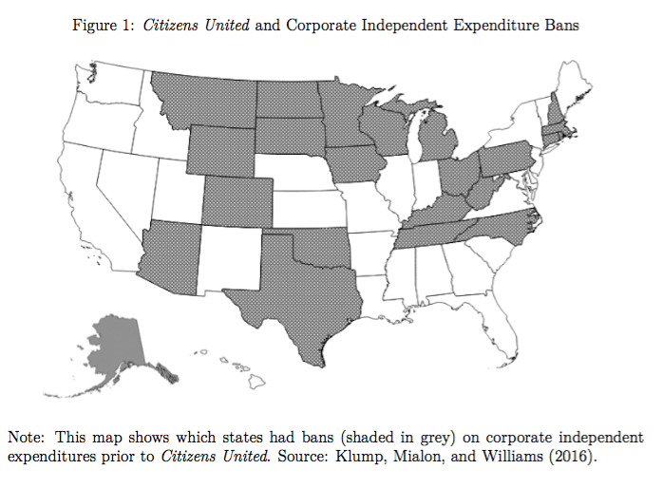

Figure 2. Average Treatment Effect (ATT) of Citizens United on State Coprporate Income Tax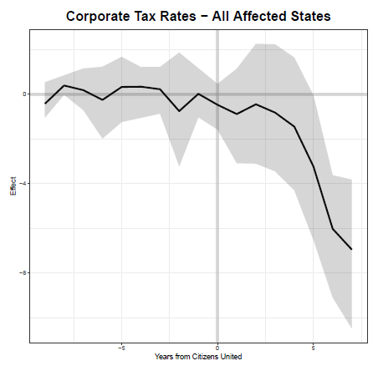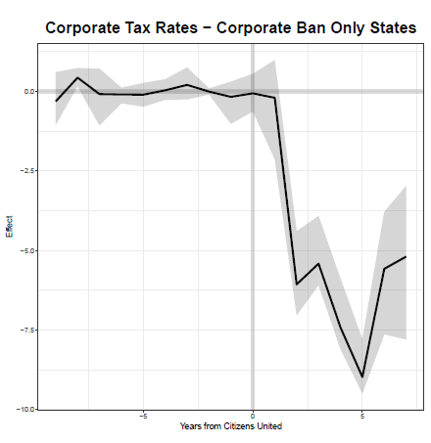
Notes: See Table 1 for details.
Figure 3. Average Treatment Effect (ATT) of Citizens United
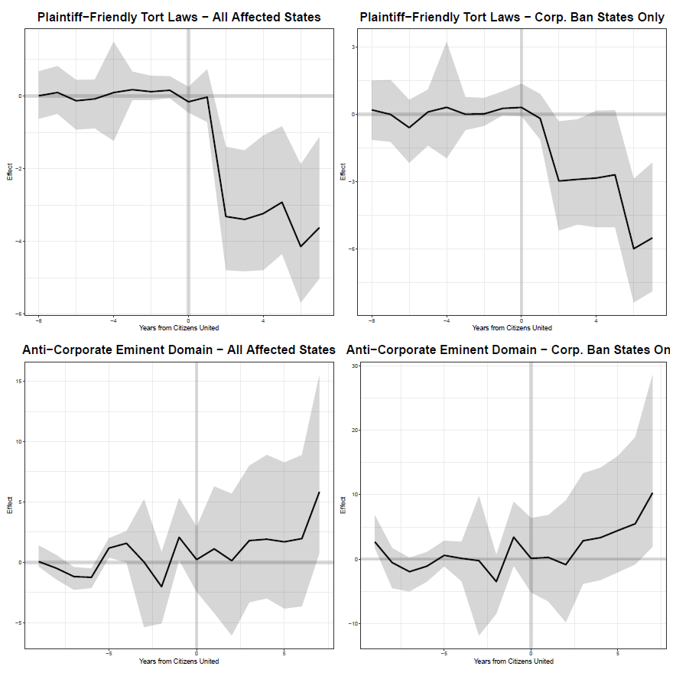

continued on next page

Figure 3 (continued)

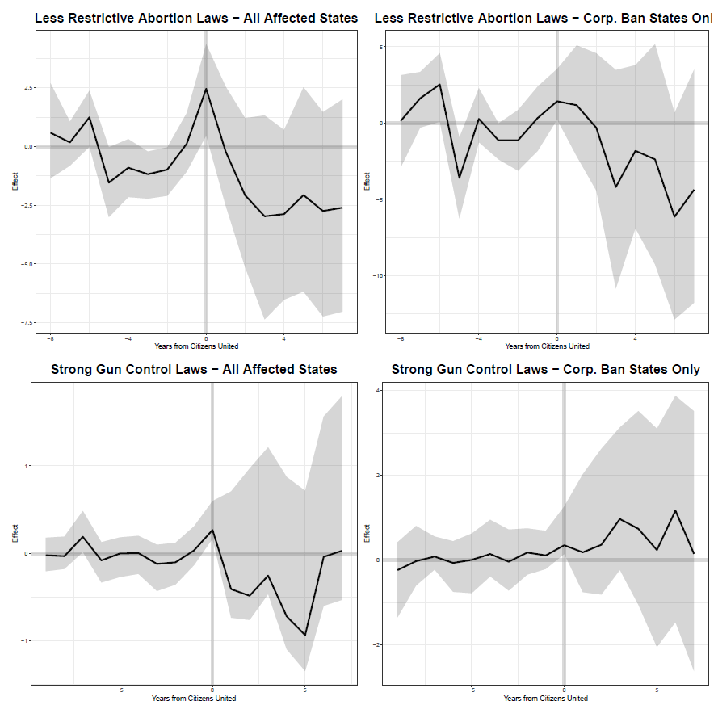

Note: See Appendix C for full results.

UCLA, gilens@ucla.edu
Vanderbilt, CSDI, shawn.t.patterson@vanderbilt.edu
University of Denver, pavielle.haines@du.edu
NOTES We also note that although the Citizens United and SpeechNow rulings pertained only to corporate and union spending, IEs by individuals have grown dramatically since those decisions were handed down. At the federal level, where the data are most complete, the vast majority of the individual IEs are from wealthy business owners and investors (Hansen et al. 2015; Hansen and Rocca 2019). Consequently, we expect changes in IEs by individuals to intensify the pro-corporate impact of the court rulings.
The National Conference of State Legislatures. 2019. http://www.ncsl.org/research/elections-and-campaigns/citizens-united-and-the-states.aspx.
These figures are based on the 15 states with consistent reporting requirements for IEs over this time period (see Malbin et al. 2018, table 2) and reflect the average expenditures in the 2006 and 2008 (pre-Citizens United) election cycles and the 2012 through 2016 cycles (post-Citizens United). We exclude the 2010 cycle, since it includes periods both before and after states changed their campaign finance laws in response to Citizens United. Data are from the Campaign Finance Institute at the National Institute for Money in Politics https://www.followthemoney.org/ downloaded on 7-3-2019. These figures are based on total IEs for governor, lieutenant governor, and state legislative races per two-year election cycle.
We are grateful to Michael Malbin for making these data available.
These figures reflect corporate IEs as a proportion of corporate plus union IEs, averaged across the ten states that were affected by Citizens United and had consistent IEs reporting requirements from the 2006 through the 2016 election cycles. See note [ 3 ] above and Malbin (2018), table 2. Using national data, Klumpp et al. (2016) also found an increase in business IEs relative to labor during this period.
As measured by Shor and McCarty (2011) NPAT Common Space scores.
Also based on NPAT scores.
More specifically, the GSC routine “impues counterfactuals for each treated unit using control group information based on a linear interactive fixed effects model that incorporates unit-specific intercepts interacted with time-varying coefficients.” (Xu 2017, p.57).
In these analyses, we omit the six states that do not tax corporations based on their income.
The corporate tax rate in our sample varied from a low of 3.4% (in Indiana from 2000 through 2003) to 12% (in Iowa with no change over our time period). Data for state corporate tax rates comes from the Tax Foundation: https://taxfoundation.org/state-corporate-rates-brackets-2019/
Data obtained from the Campaign Finance Institute and the National Institute on Money in Politics show IEs from “Attorneys and Law Firms” to constitute only about one percent of all corporate IEs. www.followthemoney.org accessed on 5-26-2019.
On gun control see Dancy et al. 2019, on abortion see Norrander and Wilcox 1999.
An exception, of course, are gun manufactures but that one industry represents a tiny proportion of all U.S. corporations.
Sorens, Jason, Fait Muedini, and William P. Ruger. 2008. “State and Local Public Policies in 2006: A New Database.” State Politics and Policy Quarterly 8: 309–26. State Policy Database. Accessed May 15, 2019. http://www.statepolicyindex.com/data/
National Conference of State Legislatures, https://www.ncsl.org/research/elections-and-campaigns/campaign-contribution-limits-overview.aspx. Accessed 2-17-2020.
National Conference of State Legislatures, https://www.ncsl.org/research/elections-and-campaigns/public-financing-of-campaigns-overview.aspx .Accessed 2-17-2020.
These figures are based on the 15 states with consistent reporting requirements for IEs over this time period (see Malbin et al. 2018, table 2). We exclude 2010 since it includes periods both before and after states changed their campaign finance laws in response to Citizens United. Data are from the Campaign Finance Institute at the National Institute for Money in Politics https://www.followthemoney.org/ downloaded on 7-3-2019. These figures are based on total IEs for governor, lieutenant governor, and state legislative races per two-year election cycle.
Malbin 2018, Table 2.

